Indexes
Indexes in finance is like any other index you know. We have an index that tells us the unemployment rate. We have an index that tells us the inflation rate. Similarly, there are indexes that monitor the performance of companies in stocks.
The very first used index in the US market in 1896 was “The Dow” index with the ticker “DJI”. However, it tracks only the biggest 30 companies, and it is price-based, which makes it not very intuitive or accurate. Nowadays, the most popular index is the Standard and Poor’s 500 or, in short, “S&P 500” index with the ticker “SPX”. It tracks the largest 500 companies in the US stock, and it is market-cap based, which means it goes up and down based on the market cap of the companies. The larger the company, the larger its market cap, and hence the larger its impact on the index. For example, Microsoft is currently the biggest market cap in the US stock, so it surely has the biggest impact on the S&P500 index. What makes the S&P500 index popular is that the largest 500 companies represent around 85% of the stocks, so looking at the largest 500 companies is as if you scanned almost 85% of the stocks, those 15% won’t matter much.
When you view a chart during a long period, the chart will most probably exhibit an exponential behavior. This might be tricky because you might think that the stock was not earning at its beginning, but then it began earning. For example, check the chart below:
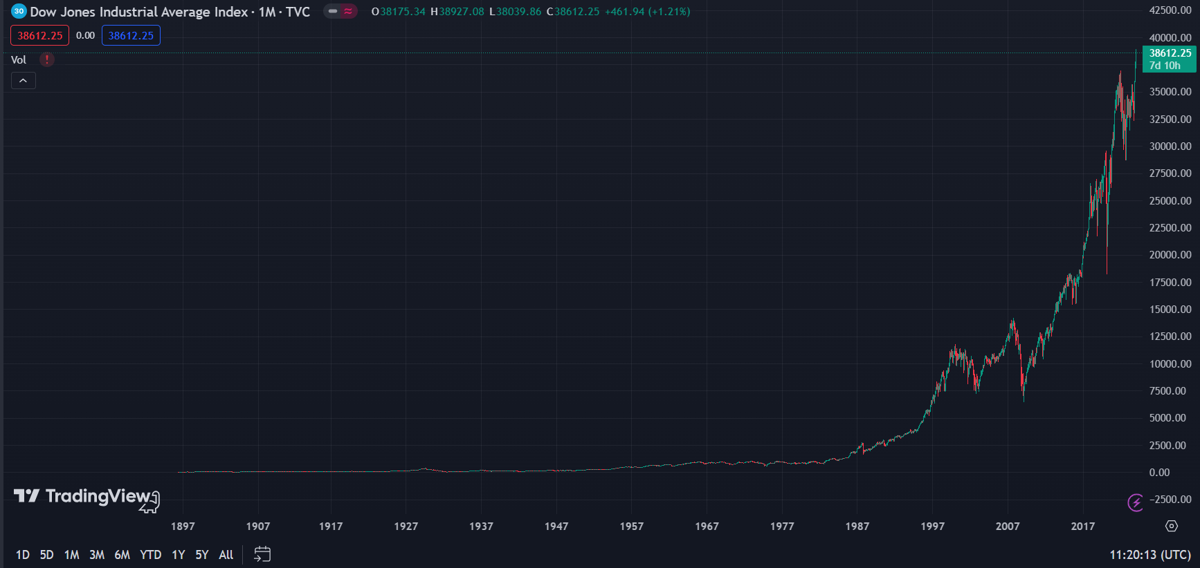
Seems like it boomed only starting from 1987, right? This is not right. It is just because you are thinking about “percentage increase”, while you are indeed looking at a chart that shows “price increase”. To elaborate more, check the chart below.
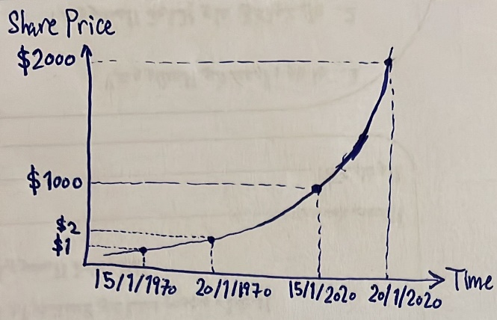
If you bought stocks on 15/1/1970 and sold it on 20/1/1970, you have made a 100% profit because the share price increased by 100%. If you bought stocks on 15/1/2020 and sold it on 20/1/2020, again, you have made a 100% profit because the share price increased by 100%. So, in both cases, your profit is the same. However, it is clear that the chart is much steeper from 15/1/2020 to 20/1/2020 than from 15/1/1970 to 20/1/1970. This is because the chart tracks the absolute value of the share price, and it makes sense that any stock begins with a small share price and increases over time, so it eventually adapts an exponential behavior. So, the profit in the previous chart might be the same at any time, the chart just might be a little misleading. Accordingly, when viewing charts during a long period, it is better to look at a logarithmic scale instead of dollars. The previous chart in logarithmic scale is shown below:
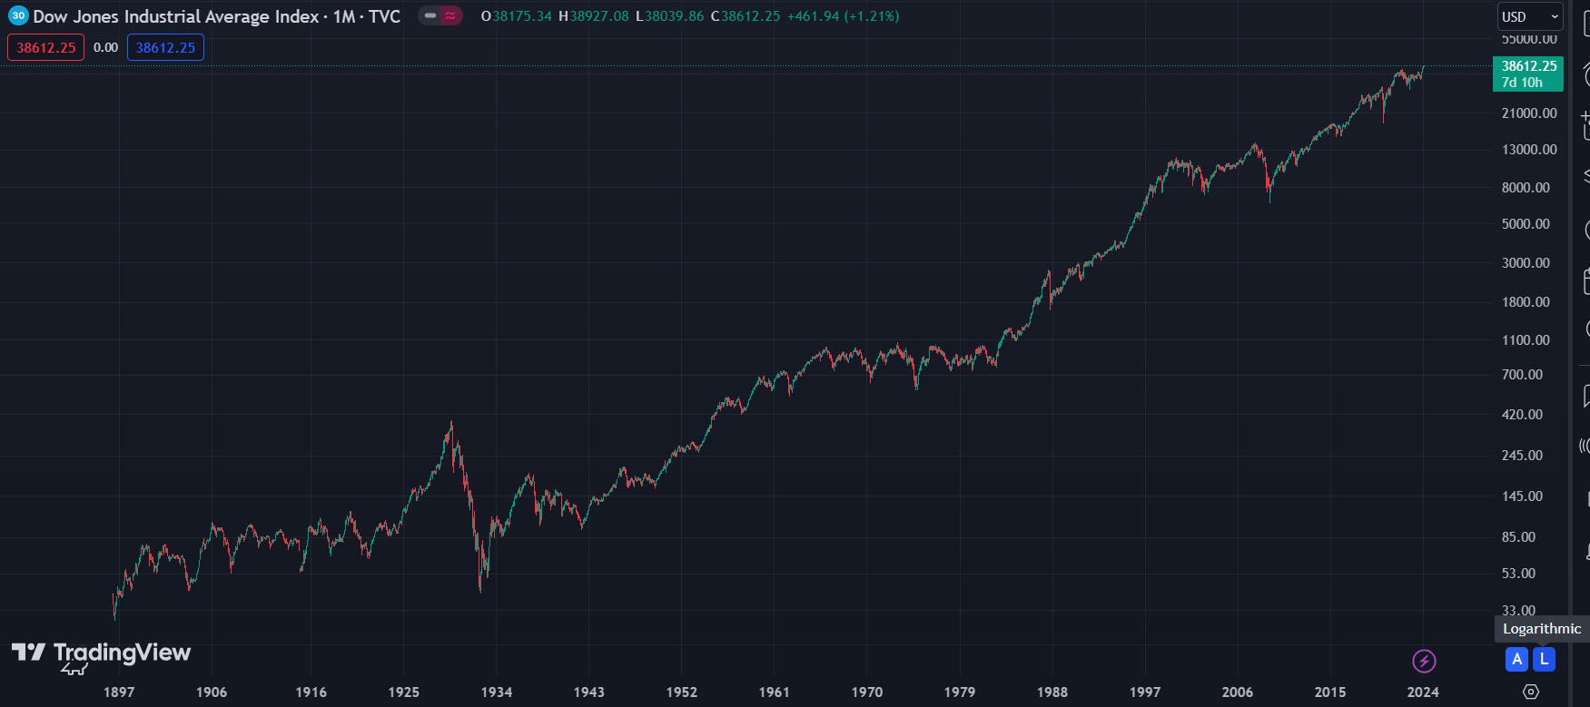
So, let’s check the logarithmic chart of the S&P500 index:
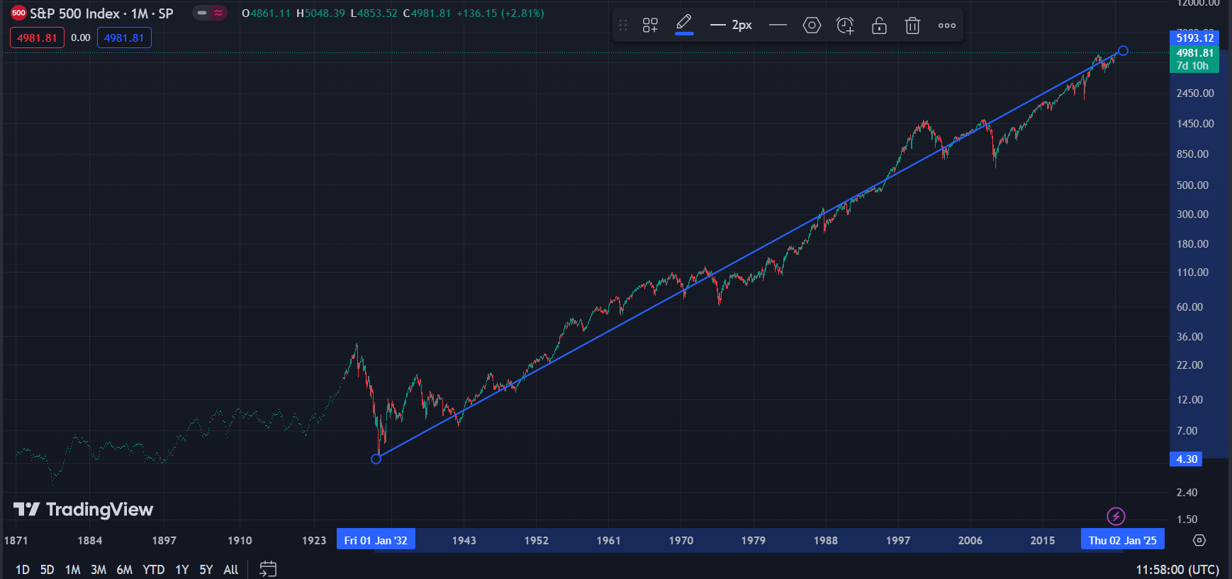
See? The market has been moving up since ever! The S&P500 index really shows you the performance of the stock market over the years. It is clear that the overall trend is always going up. There might be drops in the middle, but they are just temporary drops, it will eventually go up again. In the last 50 years, the S&P500 made an average annual profit of ~10%. So, should we stick to the market growth and invest in the S&P500 index, or can we beat the market?
Let us compare between investing in stocks versus the life insurance offer of Allianz. Shown below is Allianz’s offer. I keep paying $500 every month, which is equivalent to paying $6000 every year, for 42 years. At the end of this period, I will have paid $252,000 and get $810,000. This means I will have made a total profit of $\frac{\$810,000-\$252,000}{\$252,000}×100=221.43\%$, which is equivalent to an annual profit of $\frac{221.43\%}{42 years}=5.27\%$. See? Investing in stocks is way better, it guarantees you at least 10%!
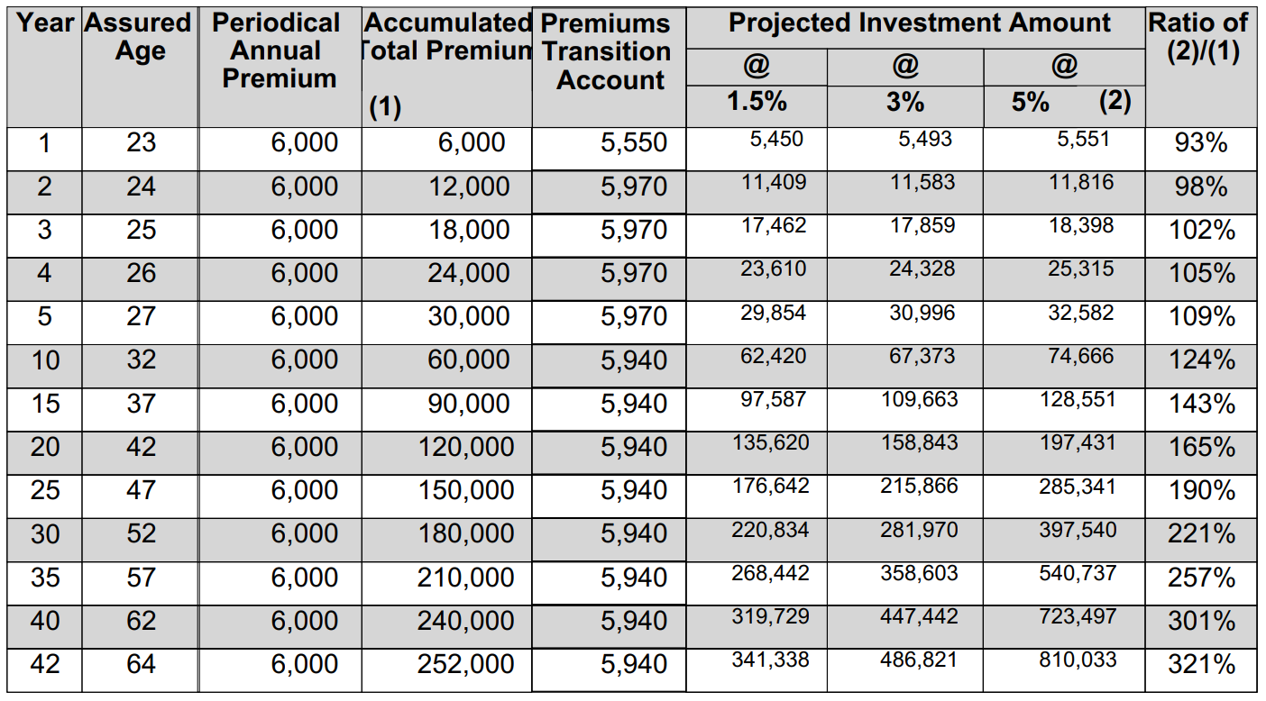

Index Funds
An index fund is a fund that seeks to replicate the performance of the index it is tracking. An index like S&P500 is just a number, we can’t invest in it, we need an investment vehicle that replicates the performance of this index, and this investment vehicle is the index funds. So, an index fund that follows S&P500 will invest in the top 500 companies in the US market with the same weight each company is given in the index. So, when the index increases by 5% for example, the index fund should make a profit of 5% as well.
So, how can you get in an index fund? There are many index funds providers but try to join big firms only because since they have many customers, the fees per customer are low. Currently, the two largest index funds providers are:
- Vanguard.
- BlackRock.
On Vanguard, you can search for mutual funds as shown below (index fund is a type of a mutual fund. We will talk about mutual funds shortly). As expected, the most popular mutual fund is the S&P500 mutual fund. Its expense ratio is 0.04%, which is super cheap. For example, if you invest $10,000 in this fund, Vanguard will charge you $4 only.
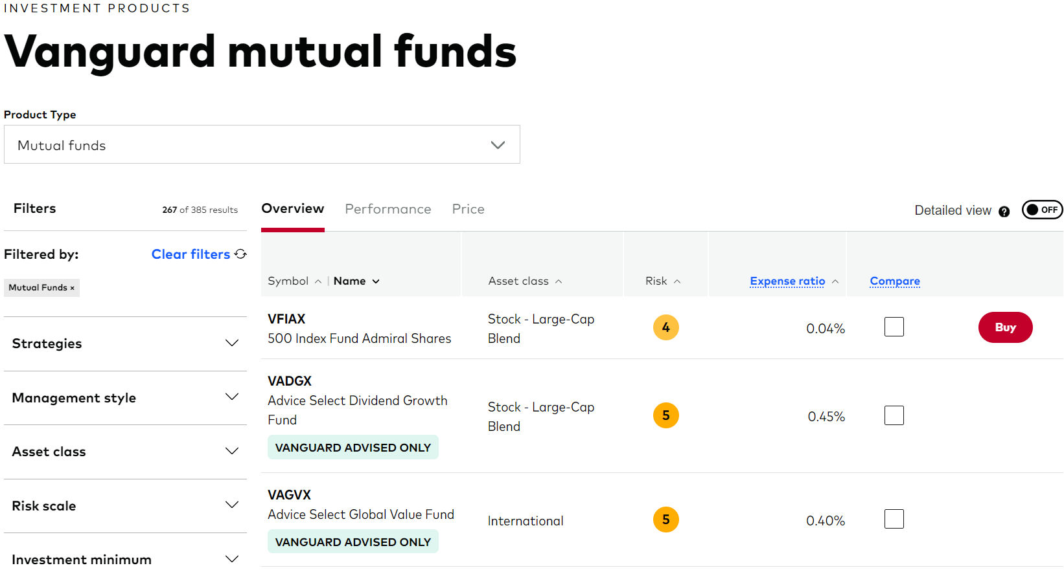
The fund’s performance is shown below. Vanguard tries to show you how close the fund’s performance to the benchmark, which is nothing but the index that the fund is tracking (S&P500 in this case). The fund’s performance might be slightly less than the benchmark’s due to the small fee. For example, the fund’s performance in 10 years is 12.58% annual profit, while the benchmark’s is 12.62%. There is an 0.04% difference, which is Vanguard’s fees.
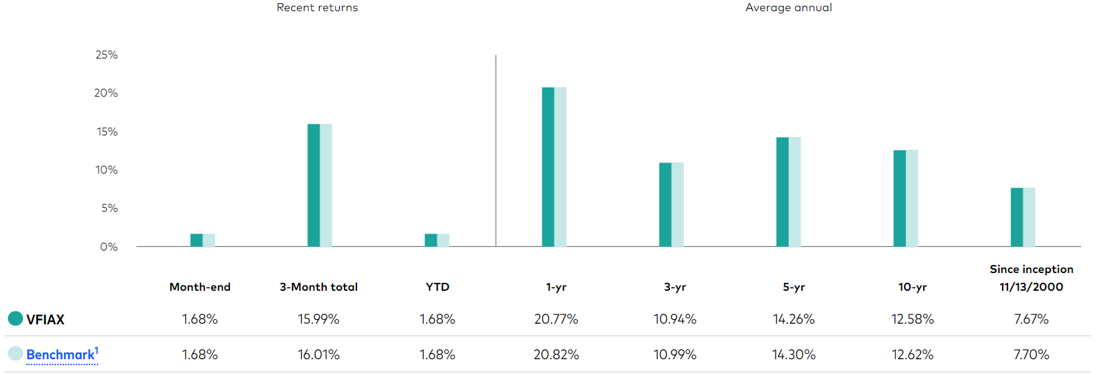

Net Worth Excel Sheet
Check the excel sheet in the folder. You just need to plug in the data on the top right (age, yearly income, portfolio fees, etc) and the table on the left will calculate to you everything. Watch the lecture for more information.

Exchange-Traded Funds (ETFs)
An ETF is an investment fund that holds assets like stocks, bonds, commodities or other investment products. ETFs can be traded on a stock exchange just like shares.
So, what is the difference between an index fund and an ETF? They are pretty much the same except that an ETF can be traded on a stock exchange just like shares. That is, an ETF has a ticker in the stock market and you can buy it through a brokerage firm just like buying shares, but an index fund doesn’t have a ticker on a stock exchange; you need to go to a fund provider to buy an index fund.
Shown below are the most popular ETFs on tradingview:
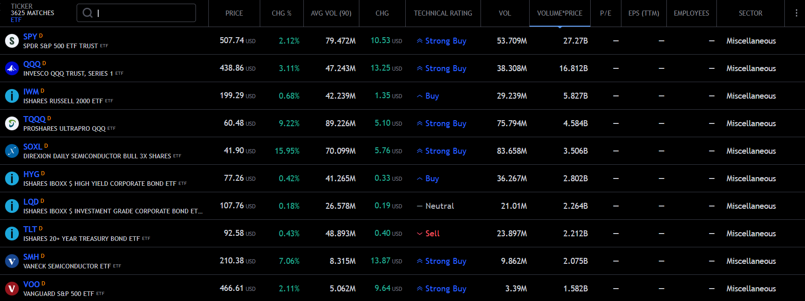
The most popular ETF is the SPY ETF, which is actually nothing but an ETF that replicates the S&P500 index. Actually, this is the first ever traded ETF. At the end of the list in the previous snapshot, you can see “VOO” ETF. It is an ETF created by Vanguard that also replicates the S&P500 index. So, SPY or VOO? The expense ratio of SPY is 0.09%, while that of VOO is 0.03%, and they are doing exactly the same thing, so definitely go with VOO. So, why is the expense ratio of SPY higher than VOO? It is just because it is older and more popular.

Mutual Funds
A mutual fund is an investment fund where investors can pool in their money and have it managed by a professional (portfolio manager).
So, what is the difference between a mutual fund and an index fund or an ETF? The difference is that an index fund or an ETF tries to replicate an index, while a mutual fund tries to beat the index. An index fund that replicates S&P500 tracks the market as we said, but a mutual fund tries to even beat the market! In a mutual fund, there is a fund manager and stock analysts that do their research on several stocks and industries to best build your portfolio. This is why the fee of a mutual fund is higher than that of an index fund. For example, the fee of a mutual fund can be 1.5%! Compare a fee of 0.03% in VOO ETF to a fee of 1.5% in a mutual fund. When does this large fee be justified? If the mutual fund makes an average profit higher than that of the ETF/index fund. For example, the VOO ETF makes an average annual profit of 10% for a fee of 0.03%. For a mutual fund of 1.5% fee to beat this, it must have an average annual profit higher than ~11.5%.
The type of mutual funds we talked about is known as open-end fund; any individual can pool in their money in this fund, and it will be managed by professionals. Another type of mutual funds is called closed-end fund. It is a fund that has a fixed unit of shares available. It does not issue new shares for individuals to add money to the fund. Individuals on the other hand can trade the shares of that fund on an exchange. A good website for closed-end funds is cefconnect.com.
So, we can divide the funds into two types:
- Index fund: a fund that replicates an index. It is also known as passive fund since no stock analysts or managers manage the fund, the fund just trivially follows the index. Accordingly, it has low fee.
- Mutual fund: it is also known as active fund since stock analysts and managers manage the fund. Accordingly, it has high fee. It can be divided into open-end funds and closed-end funds.

Beating The Market
We have seen that S&P500 tracks the market. Beating the market is trying to perform better than S&P500. That is, when it makes profit, you try to make more. When it loses, you lose less. But you have to know well that trying to beat the market is risky because you can end up making less profits than S&P500 or more losses than S&P500.
Of course, to take such a risky decision to beat the market, it must be justified to decide whether it is worth or not. Let’s use the excel sheet to do so. Let’s choose the parameters as follows for investing in S&P500 (i.e. 10% yearly return).
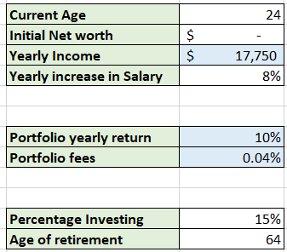
This yields a net worth of $3,648,711 at the end of the period. Now, for the same parameters, let’s just assume we found a way that can beat the market by 2% and just increase the yearly return to 12% instead of 10%. This yields a net worth of $5,646,244 instead! This is a huge impact, it is a $\frac{\$5,646,244-\$3,648,711}{\$3,648,711}=54\%$ increase in the net worth for just extra 2% in the annual return! Thus, it is for sure worth to analyze the risks as the impact is huge.

Choosing a Brokerage Firm
So far, we have talked about all the investment vehicles shown below. Don’t forget that mutual funds are divided into open-end and closed-end funds. Underlying assets means investing in stocks directly.
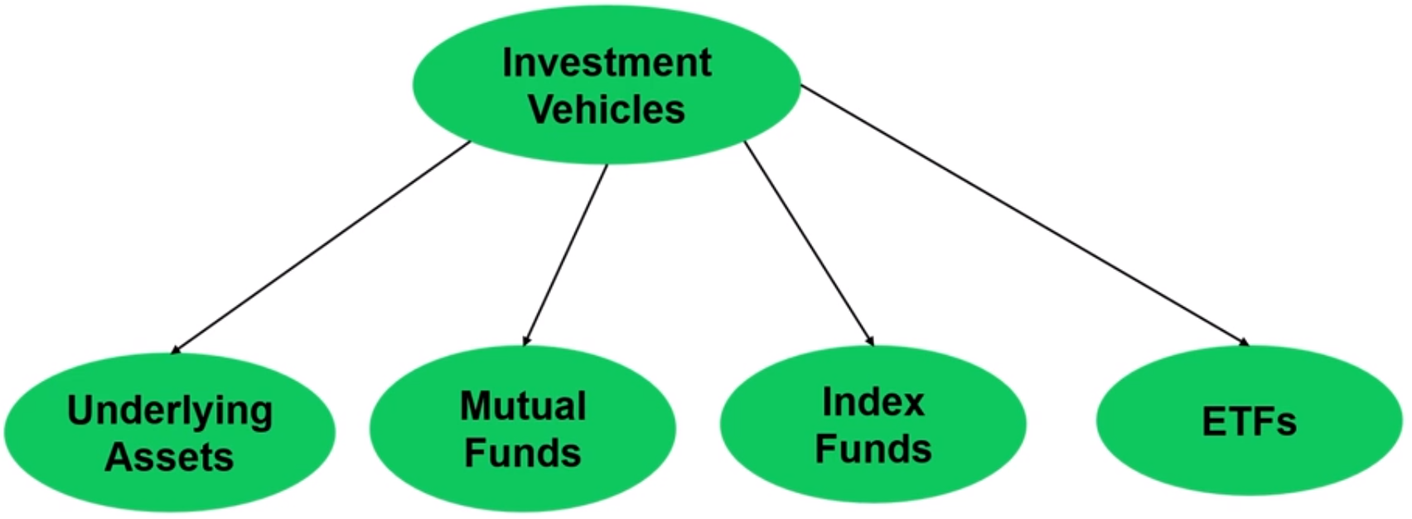
To invest in underlying assets, close-end mutual funds, or ETFs, you need a brokerage account since these are all investment products that are traded on stock exchanges. Only open-end mutual funds and index funds do not require a brokerage account.
When you’re finding a brokerage firm, you are trying to make sure that you do not pay too much. Accordingly, it is best to seek big brokerage firms since they have many customers and hence their fee per customer would be small. The most well-known brokerage website is interactive brokers. It lets you trade not only on the US market, but many other countries as well. What makes it the best is that its commission is the lowest compared to other brokerage firms. Notice that there are brokerage firms like Robinhood that cost you no commission, but they do not send your orders directly to the market. Instead, they sell them to high frequency trading firms. This delays your order and might let you miss an opportunity or getting your order filled at worse price. So, you will end up losing more with these commission-free brokers than going with a broker like interactive brokers that charges you a small commission.
Another thing is to make sure that this brokerage firm is insured so that, if any thing happens to this brokerage firm, your account is insured (at least up to a certain amount). Interactive brokers is an insured brokerage firm as shown below:
